**SPRINT 1**

**CREATING IBM CLOUD SERVICES**

|  |  |
| --- | --- |
| **TEAM ID** | **PNT2022TMID43096** |
| **PROJECT NAME** | **GAS LEAKAGE MONITORING AND ALERTING SYSTEM FOR INDUSTRIES** |

**CREATED ACCOUNT ON IBM CLOUD**

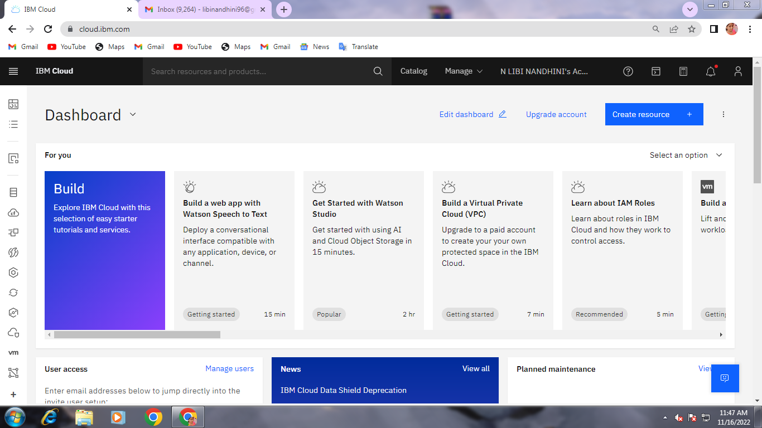

**CREATED ACCOUNT ON NODE RED SERVICE**

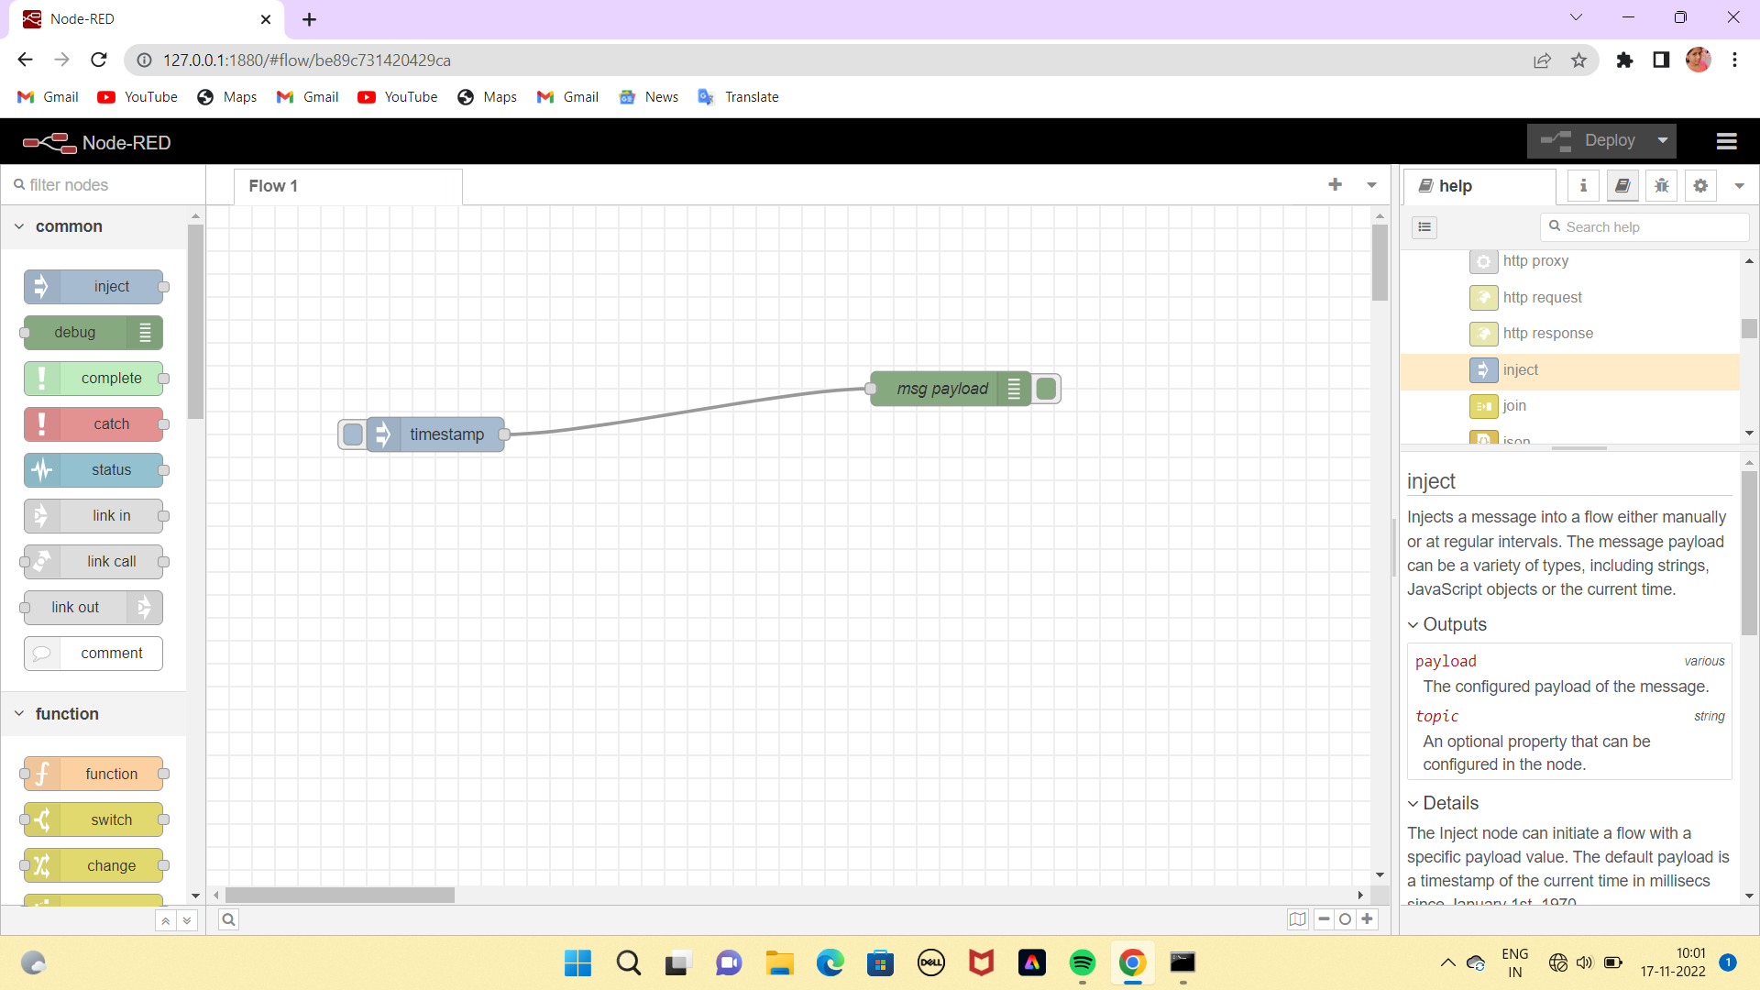

**CREATED CLOUDANT DB**

